Experiment 7

AIM: To calculate the convolution sum of two discrete-time signals

THEORY:
Convolution can be used to determine the output a system produces for a given input signal. It can be shown that a linear time invariant system is completely characterized by its impulse response. The sifting property of the discrete time impulse function tells us that the input signal to a system can be represented as a sum of scaled and shifted unit impulses. Thus, by linearity, it would seem reasonable to compute the output signal as the sum of scaled and shifted unit impulse responses. That is what the operation of convolution accomplishes. Hence, convolution can be used to determine a linear time invariant system's output from knowledge of the input and the impulse response.

Discrete time convolution is an operation on two discrete time signals defined by the integral :

If one signal has M samples and other has N samples then convolution of these two signals will have M+N-1 samples.

Finding Convolution Sum
- Define/Sketch x[k] and h[k].
- The impulse response, h[k] time -reversed or folded to obtain h[-k].
- Then h[-k] shifted by n to form h[n – k] = h[-(k- n)] which is a function of k with parameter n. Begin with shift n large and negative, i.e., shift h[-k] to the far left on the time axis.
- The signal x[k] and h[n – k] are multiplied together for all values of k with n fixed at some value/range.
- The product x[k] h[n – k] is summed over all k to produce a single output value y[n].
- For Calculating the response of the system over all instants of time, repeat steps 3 to 5 till response at all time instants (n = -∞ to ∞) is obtained.

=================================================================

IN LAB EXERCISES

1. Consider the discrete-time signals
, ,

Write a MATLAB program to perform and verify the discrete-time convolution commutativity, distributivity and associativity properties (Use conv):

clc;
clear;
n = -7:0.5:7;
f1 = (n == 0);
f2 = (abs(n) <= 0.5);
u1n = (n >= 0); u2n = (n >= 5);
f3 = u1n - u2n;
t = tiledlayout(3,4);
title(t, "Q1 - InLab - 22102109");
nexttile(1, [1, 2]);
stem(n, f1);
xlabel('n');
ylabel('\delta[n]');
title('Unit Impulse')

nexttile(5, [1, 2]);
stem(n, f2);
xlabel('n');
ylabel('{\it rect}[n]')
title('Rectangular Function');

nexttile(9, [1, 2]);
stem(n, f3);
xlabel('n');
ylabel('u[n] - u[n -5]');
title('Shifted Rectangular Function');

nexttile(3);
stem(conv(f1, f2));
xlabel('n');
ylabel('f_1[n] * f_2[n]');
title('LHS - Commutativity');

nexttile(4);
stem(conv(f2, f1));
xlabel('n');
ylabel('f_2[n] * f_1[n]');
title('RHS - Commutativity')

nexttile(7);
stem(conv(f1, f2 + f3));
xlabel('n');
ylabel('f_1[n] * (f_2[n] + f_3[n])');
title('LHS - Distributivity');

nexttile(8);
stem(conv(f1, f2) + conv(f1, f3));
xlabel('n');
ylabel('f_1[n] * f_2[n] + f_1[n] * f_3[n])');
title('LHS - Distributivity');

nexttile(11);
stem(conv(f1, conv(f2, f3)));
xlabel('n');
ylabel('f_1[n] * (f_2[n] * f_3[n])');
title('LHS - Associativity');

nexttile(12);
stem(conv(conv(f1, f2), f3));
xlabel('n');
ylabel('(f_1[n] * f_2[n]) * f_3[n]');
title('RHS – Associativity');

OUTPUT:
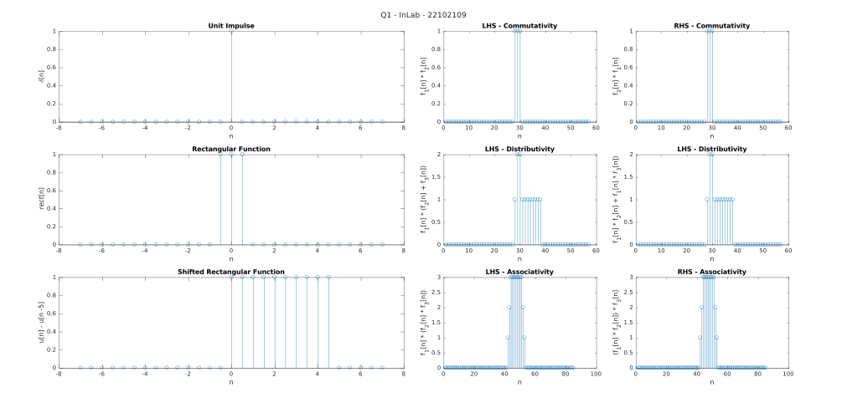

+-+-+-+-+-+-+-+-+-+-+-+-+-+-+-+-+-+-+-+-+-+-+-+-+-+-+-+-+-+-+-+-+-+-+-+-+-+-+

2. Write a MATLAB program to perform the Convolution. Plot the results obtained and comment on the convolution signal durations. Verify the results by using the MATLAB function conv.
a) and
b) and
c) and
clc;
clear;
t = tiledlayout(3, 4);
title(t, "Q2 - InLab - 22102109")

x1 = [-2 0 1 -1 3];
h1 = [1 2 0 -1];
nexttile(1);
stem(x1);
xlabel('n');
ylabel('x[n]');
title('Part (a) - x[n]');

nexttile(2);
stem(h1);
xlabel('n');
ylabel('h[n]');
title('Part (a) - h[n]');

nexttile(3);
stem(conv(x1, h1));
xlabel('n');
ylabel('x[n] * h[n]');
title('Built in conv(x, h)');

nexttile(4);
stem(convolve(x1, h1));
xlabel('n');
ylabel('x[n] * h[n]');
title('Manual convolve(x, h)');

n = -5:1:5;
x2 = (n >= 0);
h2 = exp(-n) .* x2;
nexttile(5);
stem(x2);
xlabel('n');
ylabel('x[n]');
title('Part (b) - x[n]');

nexttile(6);
stem(h2);
xlabel('n');
ylabel('h[n]');
title('Part (b) - h[n]');

nexttile(7);
stem(conv(x2, h2));
xlabel('n');
ylabel('x[n] * h[n]');
title('Built in conv(x, h)');

nexttile(8);
stem(convolve(x2, h2));
xlabel('n');
ylabel('x[n] * h[n]');
title('Manual convolve(x, h)');

x3 = cos(pi * 0.5 * n) .* x2;
tn = (n >= 1);
h3 = ((-1) .^ n) .* tn;
nexttile(9);
stem(x3);
xlabel('n');
ylabel('x[n]');
title('Part (c) - x[n]');

nexttile(10);
stem(h3);
xlabel('n');
ylabel('h[n]');
title('Part (c) - h[n]');

nexttile(11);
stem(conv(x3, h3));
xlabel('n');
ylabel('x[n] * h[n]');
title('Built in conv(x, h)');

nexttile(12);
stem(convolve(x3, h3));
xlabel('n');
ylabel('x[n] * h[n]');
title('Manual convolve(x, h)');

function cnv = convolve(a, b)
L = length(a) + length(b) - 1;
cnv = zeros(1, L);
a1 = [a, zeros(1, L - length(a))];
b1 = [b, zeros(1, L - length(b))];
for i = 1:L
c = 0;
for j = 1:i
c = c + a1(j) * b1(i - j + 1);
end
cnv(i) = c;
end
end

OUTPUT:
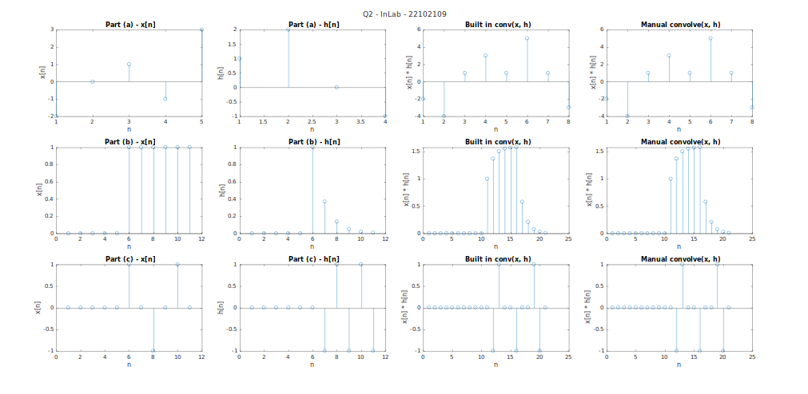

=============================================================================

POST LAB EXERCISES

1. Consider two LTI systems with the unit sample responses
and
These two systems are cascaded as shown in figure. Let
- Compute y[n] by first computing w[n] = x[n] * h₁[n] and then computing y[n] = w[n] * h₂ [n]; that is y[n] = [x[n] * h₁[n]] * h₂ [n].
- Now, find y[n] by first convolving h₁[n] and h₂[n] to obtain g[n] = h₁[n] * h₂[n] and then convolving x[n] with g[n] to obtain y[n] = x[n] * [h₁[n] * h₂ [n]].

clc;
clear;
n = -10:1:10;
un = (n >= 0);
h1 = ((-0.5) .^ n) .* un;
un5 = (n >= 5);
h2 = un - un5;
xn = (n == 0);
clearvars un un5;
t = tiledlayout(2,1);
title(t, "Q1 - PostLab - 22102109");
wn = conv(xn, h1);
yn = conv(wn, h2);

nexttile(1);
stem(yn);
xlabel('n');
ylabel('[x[n] * h_1[n]] * h_2[n]');
title('Part - a');
clearvars yn;

gn = conv(h1, h2);
yn = conv(xn, gn);
nexttile(2);
stem(yn);
xlabel('n');
ylabel('x[n] * [h_1[n] * h_2[n]]');
title('Part – b');

OUTPUT:
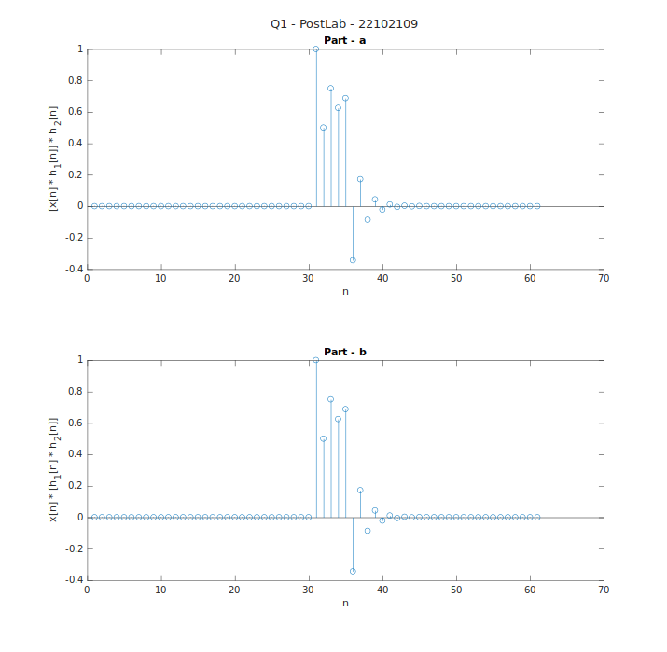

+-+-+-+-+-+-+-+-+-+-+-+-+-+-+-+-+-+-+-+-+-+-+-+-+-+-+-+-+-+-+-+-+-+-+-+-+-+-+

2. Write a function to calculate convolution sum of two DT sequences,
and

clc;
n = -7:1:7;
u2n = (n >= -2);
u4n = (n >= 4);
xn = (2 .^ n) .* (u2n - u4n);
clearvars u2n u4n;
hn = zeros(1, length(n));
for i = 1:length(n)
if(n(i) < -1)
hn(i) = 0;
elseif(n(i) < 4 && n(i) >= -1)
hn(i) = n(i) .^ 2;
elseif(n(i) < 6 && n(i) >= 4)
hn(i) = 3;
else
hn(i) = 0;
end
end

t = tiledlayout(3, 2);
title(t, "Q2 - PostLab - 22102109");
nexttile(1, [1,2]);
stem(n, xn);
xlabel('n');
ylabel('x[n]');
title('2^n * (u[n+2] - u[n-4])');

nexttile(3, [1, 2]);
stem(n, hn);
xlabel('n');
ylabel('h[n]');
title('{\it Piecewise-Defined} h[n]')

nexttile(5);
stem(convolve(xn, hn));
xlabel('n');
ylabel('x[n] * h[n]');
title('Manual Convolve Function');

nexttile(6);
stem(conv(xn, hn));
xlabel('n');
ylabel('x[n] * h[n]');
title('Built-In Convolve Function');

function cnv = convolve(a, b)
L = length(a) + length(b) - 1;
cnv = zeros(1, L);
a1 = [a, zeros(1, L - length(a))];
b1 = [b, zeros(1, L - length(b))];
for i = 1:L
c = 0;
for j = 1:i
c = c + a1(j) * b1(i - j + 1);
end
cnv(i) = c;
end
end

OUTPUT:
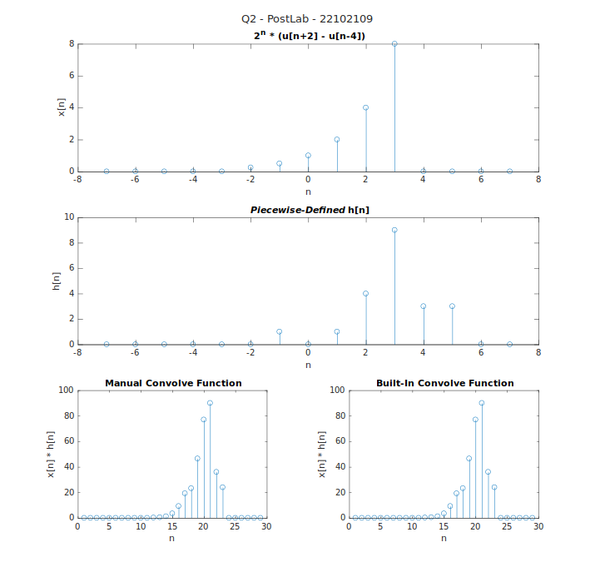

=============================================================================

RESULT: In the MATLAB experiment, the convolution sum of two discrete time signals was successfully computed. The result represents the output signal formed by convolving the input signals, demonstrating the linear time-invariant system's response.

LEARNING OUTCOME: Learning Outcomes of this experiment are:
- Developing proficiency in using MATLAB for signal processing tasks.
- Gaining practical experience in convolving discrete time signals.
- Insight into how convolution affects signal characteristics.
- Real-world application of convolution in filtering and system analysis.

